KwaZulu-Natal Investment Monitor

December 2012

Fixed investment worst in two and a half years
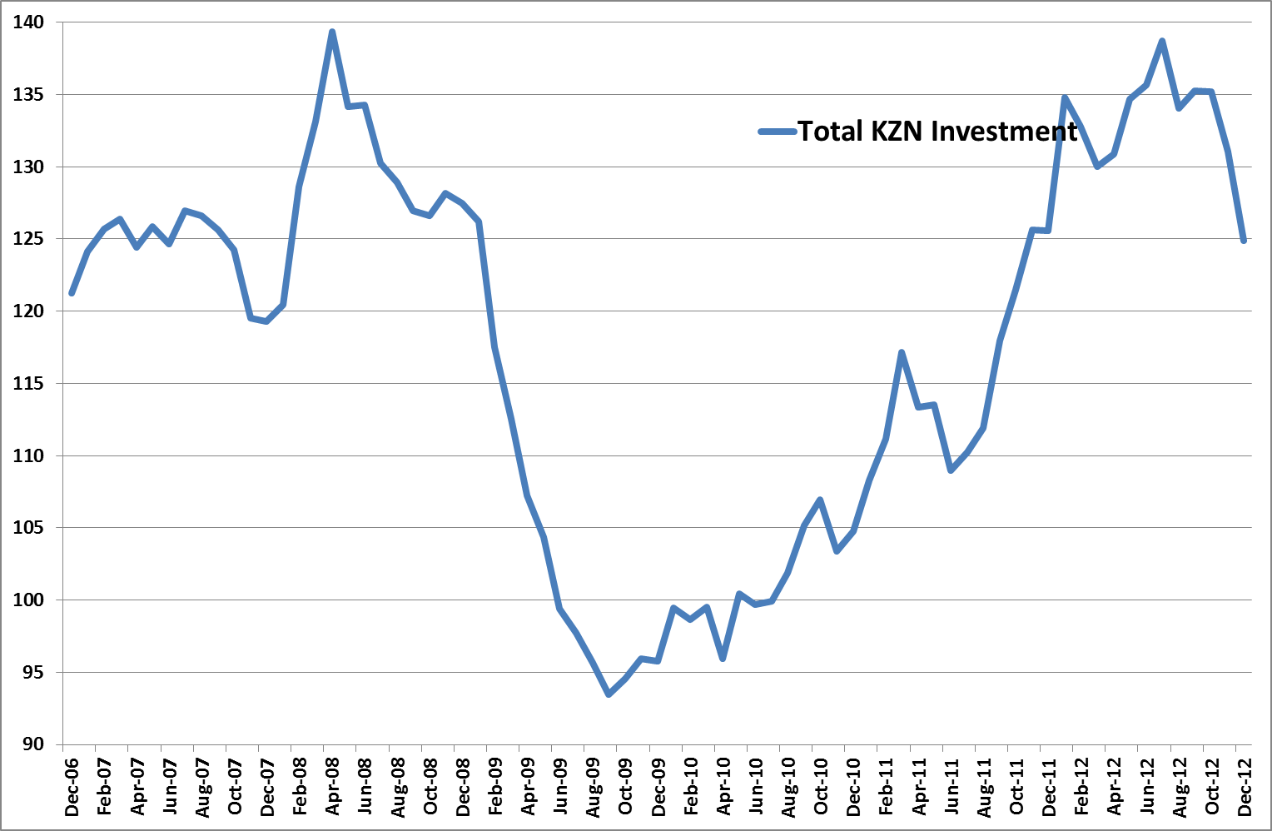
Fixed investment in KwaZulu-Natal had its worst performance in more than two and a half years as the strikes in the second half of last year and credit downgrade weighed on the rand’s exchange rate.
The latest total investment index of the KwaZulu-Natal investment monitor, as compiled by Mike Schssler of Economists.co.za, declined by 0.6% year-on-year after two years of mostly double-digit growth. Quarter-on-quarter the index was down 7.7%, the fifth consecutive month of decline.
Most sub-indices of fixed investment in KwaZulu-Natal did not have a positive last quarter in 2012. Aside from marginal quarter-on-quarter growth in transport equipment and transfers investment, all sub-indices were negative on a three-month basis. This was not due to any base effects, but reflects the adverse economic events and lack of economic growth in the last quarter. However, this was far from limited to KwaZulu-Natal as the whole country was struggling in the last quarter of 2012.

Transport equipment investment not top priority for struggling businesses
Investment in transport equipment struggled for a large part of 2012. After low growth in October and November, the investment category turned negative again and declined by 3.4% year-on-year. This could be an indicator of businesses cutting back on expenditure and also of less business activity as some smaller businesses are likely to have closed down. Some businesses are also selling their vehicles, or continue to use older equipment just to keep the business going.
Investment in airplanes and ships made a strong contribution to the investment in transport equipment in KwaZulu-Natal for several months last year, but this has come to an end, most likely as Comair’s fleet renewal programme came to an end. Investment in airplanes and ships declined by 13.7% year-on-year.

Buildings investment growth remains positive
Investment in buildings was the strongest year-on-year performer among all the investment categories in KwaZulu-Natal. This investment category had a good 2012, but the 5.8% year-on-year increase was the smallest of the whole year. Quarter-on-quarter investment in buildings was down 11.7%.
The slower year-on-year growth in buildings was mainly due to a 60% fall in non-residential buildings, which shows there was no commercial building activity. The quarter-on-quarter fall was exacerbated by the fact that building activity always taper down over December.
Residential buildings dropped by 20% year-on-year, a trend which is also reflected in the number of transfers and mortgage applications taking place.
Lumber sales were up 2.6%, an indication that some unreported/ unofficial building is still taking place in KwaZulu-Natal.

Short-term growth for transfers investment
Investment in transfers, which contributes only around 2% to the total investment index, declined by 2.6% year-on-year, but gained 3.7% quarter-on-quarter. The year-on-year decline shows that there is very little activity in the residential housing sector. Most consumers have bigger things to worry about and have simply too much debt to be buying houses at the moment. Apart from some transactions by higher-income groups, the decline in transfers should continue for a while.

Road maintenance can’t keep civil construction investment afloat
Investment in civil construction in KwaZulu-Natal also did not perform well in December when compared to the double-digit growth for most of last year. Year-on-year investment in civil construction grew by 2.1%. Although this was better than the previous month’s 1.6% growth, it was still not very good. Quarter-on-quarter investment in civil construction declined by 0.4%.
The low year-on-year growth shows there is simply no major infrastructure development happening. The little construction that is happening, like routine road maintenance, is just enough to keep the sector going, but not really adequate to ensure growth.

Weak rand pushes machinery and ICT equipment investment down
Investments in machinery and ICT equipment are both very dependent on the rand’s exchange rate. Investment in machinery declined by 2.6% year-on-year. This was the second consecutive month of decline after it grew by double digits for most on 2012. Investment in ICT equipment, which also enjoyed double-digit growth for most of last year, grew by only 2% year-on-year.
The slowdown in investment in these two categories is expected to continue in 2013 as the rand’s exchange rate fell to more than R9 to the dollar early in the year already.
The initial weakening of the currency last year led to some pre-emptive purchasing of machinery and ICT equipment in anticipation of further weakening, but that has now come to an end. Aside from the fact that machinery and ICT equipment are often expensive, the weak currency is making it even more expensive, making it logical for businesses to cut back on investment. A lot of businesses are simply maintaining their existing equipment and using it for longer. The lack of investment in machinery and ICT equipment could also be a cost-cutting measure, as buying less equipment means businesses have a little bit more money at their disposal.

December 2012 Results Table:

