KwaZulu-Natal Barometer

January 2013

Short-term improvement for KwaZulu-Natal economy

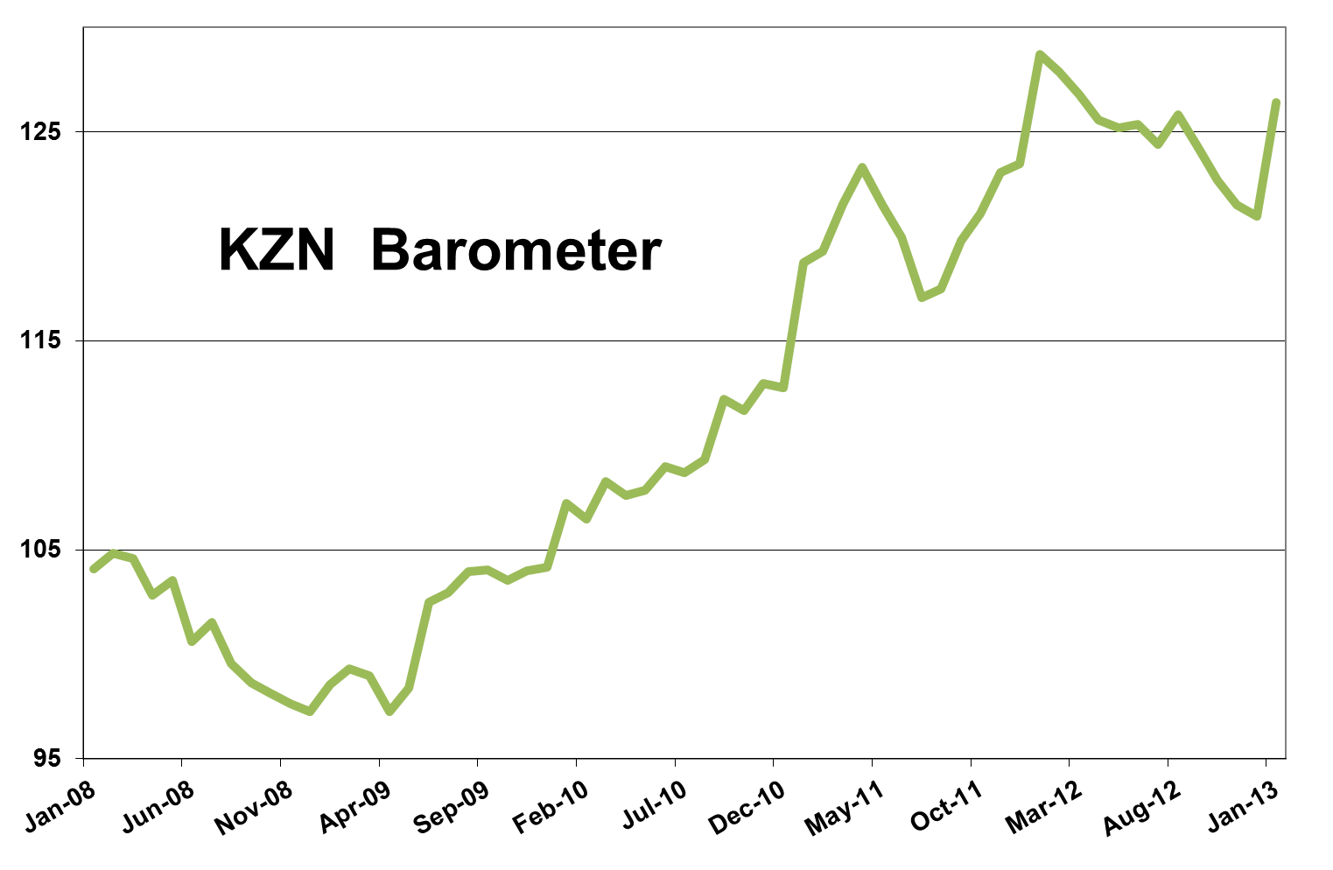

The KwaZulu-Natal economy bounced back in the most recent quarter when compared to the three months between August and October last year, but when compared to a year ago, economic activity in the province has slowed.
In the latest KwaZulu-Natal barometer, as compiled by Mike Schssler of Economists.co.za, most sub indices were positive on a quarter-on-quarter basis. This was due to the low base created in August, September and October last year as strikes in the mining, manufacturing and agriculture sectors stunted economic growth countrywide. The KwaZulu-Natal economy grew by 4.2% quarter-on-quarter, after contracting quarter-on-quarter for nine consecutive months. The KwaZulu-Natal barometer also turned positive, with 3% quarter-on-quarter growth, after four months of decline.
The 12-month picture is, however, less encouraging. The barometer declined by 1.8% year-on-year, even though the KwaZulu-Natal economy still grew by 2.2% year-on-year.

Economic stress spikes
The fall in the barometer was mainly due to a sharp increase in economic stress compared to the beginning of last year. The KwaZulu-Natal stress index increased by 4.1% on a year-on-year basis and was also up on a quarter-on-quarter and month-on-month basis. The stress index measures the effect of factors like interest rates, the inflation rate and unemployment on the economy. The last time the stress index was down on a year ago, was in August last year, just after the Reserve Bank cut the repo rate to 5%, with the prime interest rate at 8.5%, in July. While the KwaZulu-Natal inflation rate of 5.4% is lower than in the last four months, the continued increase in prices, especially administered prices like electricity and fuel, is putting pressure on consumers’ pockets. Unemployment in KwaZulu-Natal also increased over the last eight months and stood at 22.9% in January. Unless inflation drops and the unemployment rates go down by at least two percentage points, economic stress in KwaZulu-Natal will not decline soon.

Agriculture shows short-term upward curve
Agriculture in KwaZulu-Natal enjoyed some short-term gains as the volumes of cattle and sheep slaughtered during the holiday season of December and January increased. Month-on-month the agriculture index was up 2.5% and quarter-on-quarter it gained 0.7%. However, on a year-on-year basis the agriculture index fell by 4.7%, the 20th consecutive month of decline. Although KwaZulu-Natal’s agriculture sector was not affected by last year’s strikes in the sector like some other provinces, 2012 was not a very good year for farming. As in most provinces, irregular weather patterns affected crops like maize in KwaZulu-Natal, exacerbating the downward trend in agriculture.

Mining in KZN still suffering from the strikes’ ripple effect
The KwaZulu-Natal mining index consists mainly of coal; and while strikes were not widespread in the coal mining sector, it did affect production at some of the province’s mines in 2012. The mining index was down 6.9% year-on-year and 2% on a quarter ago. Some negativity will remain in the mining sector at least until there is some real positives news for the sector countrywide and everybody is officially back at work and the big mines back in full production.
Manufacturing receives small boost
The manufacturing sector’s performance is often linked to that of the mining sector, especially in a province like KwaZulu-Natal with big aluminium smelters. Despite the dismal performance of the mining sector, the KwaZulu-Natal manufacturing index picked up and increased by 2.6% year-on-year, as well as increasing on a month-on-month and quarter-on-quarter basis. The most notable contributor to the growth in manufacturing was in the categories of petroleum, chemical products, plastic and rubber, which was up by 9.5%, furniture and other manufacturing industries, which includes tobacco, which increased by 15.4%.

Electricity continues year-on-year downward streak
Activity levels in mining and manufacturing is a good indicator of electricity usage, as these sectors are both energy intensive. However, the electricity price hikes of the last five years have led to industries re-evaluating and limiting their electricity usage. The electricity index in KwaZulu-Natal has been declining year-on-year for most of the last year and was down 2% in January. The index was positive on a month-on-month and quarter-on-quarter basis but electricity usage in KwaZulu-Natal was down 3.5% for 2012 as a whole, compared to a decline of 0.9% in 2011. This shows that 2012 was indeed a very tough year for South Africa as a whole and most households and businesses were trying to cut their costs as power became more expensive.

Construction’s spike not long-lived
After a brief respite in the previous month, the KwaZulu-Natal construction index turned negative again. Year-on-on-year the index was down 7.6%, quarter-on-quarter it was down 9.4%, and month-on-month it was down 9.2%. The index is also still 16.6% below its level of three years ago. The holiday season resulted, as per usual, in less construction taking place as workers take annual leave, leading to a short-term decline in building activity. In addition, the number of buildings completed was down 10.6% from a year ago as the industry simply continues to struggle. Lumber sales, which were a positive part of the construction sector for a long while now, also turned negative and declined by 0.4% on a year ago.

Transport and communication rise on the back of steady communication increase
The transport and communications index continues to be supported by communications as page impressions on local browsers and the use of cell phone minutes kept on rising throughout South Africa. Communications increased by 9.7% on a year ago. The volume of cargo handled at KwaZulu-Natal’s two ports was down 3%. This is linked to the strikes and its longer term effect on manufacturing, which in turn affects the workings of the harbours. This is expected to turn around as the year proceeds.
Airport arrivals at King Shaka International Airport were down 10.4%, the 11th consecutive month of decline.
Overall the transport and communications index increased by 3.6% year-on-year and was up quite substantially on a month-on-month and quarter-on-quarter basis, but the increases were mainly due to communications.

Holiday season helps trade show small increase
The KwaZulu-Natal trade index was pushed mostly by petrol sales, which were up 2.8% thanks to increased driving over the holiday season, and wholesale, which grew by 3.7%. Vehicle sales grew by 5.8% and retail sales were down 2.1%.
The index as whole grew by only 0.1% year-on-year, its worst performance in almost three years. However, the trade index was still 18.1% higher than it was three years ago, showing how fair confidence in the sector has recovered since the recession.

Housing market increase surprises in finance, real estate and business services
The KwaZulu-Natal finance, real estate and business services index was up 5.5% year-on-year and also grew on a month-on-month and a quarter-on-quarter basis. The big surprise in this index was the 4.3% growth in property transfers despite the general lack of positive movement in the housing market, as the 11.7% decline in mortgages shows. This could have been the result of a big batch of transaction being finalised at the same time.
Insurance and asset management was up 17.4%, which could be ascribed to the recent record-level highs reached by the JSE, improving confidence performance in the sector countrywide.

Recovery in government spending
The KwaZulu-Natal government index have not been doing well in recent months and even turned slightly negative in December. However, it recovered and grew by 2.7% year-on-year, 8.6% month-on-month and 7.3% quarter-on-quarter. The return of government spending in KwaZulu-Natal came about as government now have a better idea of what has already been consumed and spent; and with the end of the government’s financial year in March nearing, the remaining budget will most likely be spent quicker than in recent months.

Results Table: January 2013

