KwaZulu-Natal Barometer

March 2013

Activity in KwaZulu-Natal economy picking up

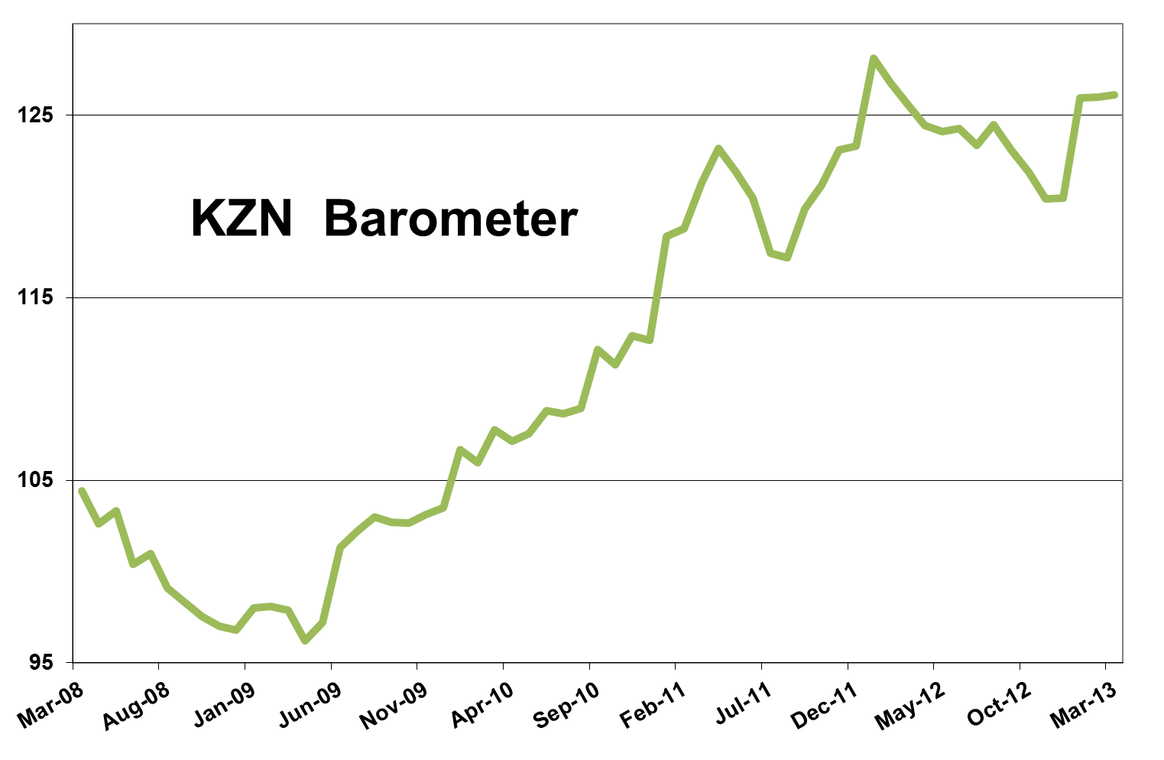

Activity in the KwaZulu-Natal economy started to pick up slightly in March after a disappointing January and February. The latest KwaZulu-Natal barometer, as compiled by Mike Schüssler of Economists.co.za, increased by 0.4% year-on-year. Although this was not much of an increase, it was at least positive after four months of decline. Quarter-on-quarter the barometer was up 4.7% and month-on-month 0.1%.

The KwaZulu-Natal growth index was up 4.2% year-on-year, the best growth in six months. The quarter-on-quarter growth of 6% shows the situation in the KwaZulu-Natal economy is far from hopeless and it’s is a good sign of what is likely to happen in coming months.

Agriculture’s surprising growth spurt not to be long-lived
Agriculture in KwaZulu-Natal is one of the sectors that is showed a surprising and welcome uptick. After declining for almost two years, the agriculture index increased by 1.8% year-on-year. The index grew by 3.6% quarter-on-quarter and 0.2% month-on-month. One of the factors restraining growth in KwaZulu-Natal’s agriculture index was a 30% drop in pork production, most likely linked to some livestock disease problems. The volume of crushed sugarcane was also down, by 14%. However, maize production gave the agriculture index a welcome kick as the production of white maize increased by 26% on a year ago.
Although the increase in the agriculture index is encouraging, the drastic increase in farmworkers’ wages will affect agriculture production going forward, as it will increase the operation and labour costs of farms. Instead of agriculture staying positive long-term, the wage increases are likely to start dragging it down again.

Mining disappoints
The KwaZulu-Natal mining industry is still reeling from the knock-on effects of last year’s prolonged strikes in the sector. The mining index was 25.9% down on a year ago, compared to the previous month’s 15.4% decline. The sharp decline in mining seems to be unique to KwaZulu-Natal as mining production increased nationally in the last reporting month. Quarter-on-quarter the mining index was down 23% and month-on-month some hope shone through with a 5% increase.

Mining dragging down manufacturing’s growth
The KwaZulu-Natal manufacturing index is reflecting the negativity of the mining index. The manufacturing index grew by a measly 0.7% year-on-year, which shows that the sector is definitely struggling. The sector’s struggles are connected to the lack of production material factories are getting from mines and this will take a while to improve. Mining will first have to pick up and only then can the manufacturing sector be expected to improve.

Electricity usage on downward slope
Both mining and manufacturing are electricity intensive sectors, so the decline in mining and slow growth in manufacturing is affecting electricity usage in KwaZulu-Natal. However, rising prices are also playing a big role. According to Stats SA, the total volume of electricity that was delivered by Eskom to the provinces decreased by 6.8% year-on-year, the biggest decrease since February 2009. This shows people and business are cutting down on electricity usage. The KwaZulu-Natal electricity index was down 3.5% year-on-year and has now been in a non-stop decline for a year.

Construction industry suffering
The construction sector is still struggling and the construction index was down 7.9% on a year ago compared to the previous month’s 18% decline. Quarter-on-quarter the construction sector was down 20.7%. Buildings completed was down 7.5% and lumber sales 8.6%, which shows the extent of the slump the construction industry is in. For businesses in the construction sector this is still a very difficult time and many are just hanging on.

Pat on the back for transport and communication
The KwaZulu-Natal transport and communication index was a rare ray of light and increased by 10.7% year-on-year, 17.8% quarter-on-quarter and 3.5% month-on-month. Communication was once again the driving force behind this index as it grew by 16.8%. This was mostly thanks to the healthy growth in local browsers, which show that more and more people have internet at their homes, even though it is still not cheap.
Passenger arrivals at the King Shaka International Airport were still in decline, but the 5.9% decline was the smallest in nine months.
Despite the lacklustre performance of the mining and manufacturing sectors in KwaZulu-Natal, cargo volumes at the province’s two ports increased by 7.6%, which is a very good sign.

Wholesale growth shows improved trade confidence, despite retail drawback
The increase in cargo volumes at ports may have something to do with the performance of wholesale sales in KwaZulu-Natal. Wholesale forms part of the trade index, which was up 2.9% year-on-year. The drivers of trade growth were vehicle sales, which grew by 6.5%, and wholesale sales, which was up 7.6%. This is a sign that some activity is happening in the sector and is a sign of improved trade confidence.
However, the performance of retail sales keeps on killing some of that confidence. Retail sales were down 2.3% month-on-month and grew 0.1% year-on-year, an improvement from the negative sales growth following the December rush of retail sales. The improvement was, however, still marginal. This is a countrywide phenomenon which shows that consumers are rather holding on to their money to deal with their debt levels.

Finance, real estate and business services look gloomy
The financial, real estate and business services index is still not doing too well and was down 0.4% year-on-year. This is also a countrywide problem. Most real estate companies and small businesses in the private sector are not doing too well.

Government spending – the saving grace for the KZN economy
After several months of slower growth, the government index in KwaZulu-Natal was back to double-digit growth at 10.2%. Quarter-on-quarter it was up 10.7% and month-on-month 2.4%. The spending by the national, provincial and local government in KwaZulu-Natal is determined from the National Treasury’s provincial budgets. Spending by the government increased markedly in the last quarter of the government’s financial year, which stretches from January to March. If it was not for the strong growth on government spending, the KwaZulu-Natal barometer might have been negative.

Stress index still on the increase
On the other side of the coin, the stress index drastically worsened the overall performance of the KwaZulu-Natal barometer. The index, which measures factors like inflation, civil debt cases, interest rates and unemployment, was up 3.7% year-on-year, the seventh consecutive month of increase.
The main component driving the growth in the stress index was inflation, which is dangerously close to the upper end of the Reserve Bank’s 3% to 6% inflation target band. Inflation is very likely to breach 6% soon. If that happens, the overall barometer will not be positive.
Civil debt cases were down 10.8% and while this is a positive development, it was still not enough to counteract the effect of rising inflation.

Results Table: March 2013

