

Sectional Title Rental Pool Villa's Now Released
As an eLan Investor Club member, you are entitled to a preferential pre-launch introduction offer on the purchase of a sectional title, 3 bedroom 180 sqm self catering villa at the existing Praia Do Cossa Resort in Bilene, 140km North of Maputo. Place your investment in the resorts rental pool and earn monthly dividends which are forecasted to yield from 9% to 12% from year one.
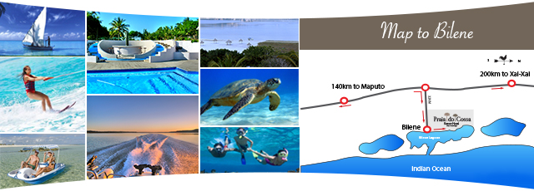
To take up this offer and to receive a full sales pack, contact us and be the first on the launch invitation guest list for Johannesburg, Pretoria, Nelspruit and Durban which kicks off on 14th August 2013.
Email: thomo@elan.co.za
Cel: +27 61 427 2470 | Office: +27 31 576 9600
www.praiadocossa.co.za
Unsubscribe from the investor club


