KwaZulu-Natal Business Barometer

December 2013

Consumers hold back KwaZulu-Natal economy
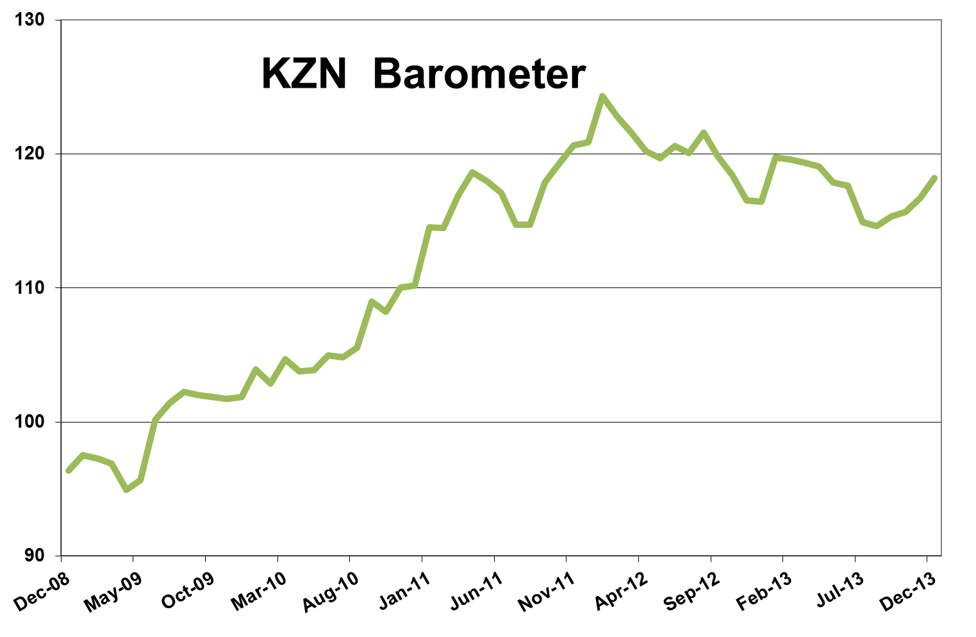
The KwaZulu-Natal economy showed some growth in the final month of 2013, but was held back by consumers who are generally in a difficult financial position. The latest KwaZulu-Natal barometer, as compiled by Mike Schssler of Economists.co.za, grew 1.5% year-on-year, the best growth in 15 months, and also grew on a month-on-month and quarter-on-quarter basis. The barometer usually grows strongly in December, so the low growth number reflects the fact that most consumers are in debt, and so being cautious. The fact that the petrol price was already expected to increase in 2014, also contributed to slow consumer spending, something that is most likely visible throughout South Africa.
Decline in stress index not to last
KwaZulu-Natal’s growth index was up 1%. The fact that the Barometer grew somewhat stronger was thanks to a decline in the stress index, the first year-on-year decline in 15 months. The decline is however not expected to last because the weaker rand will drive up inflation this year. Even the Reserve Bank drastically lifted its inflation expectations. The recent increase in interest rates which could be the start of a cycle of tighter monetary policy will also lead to increased economic stress.
Agriculture’s growth strong
Agriculture in KwaZulu-Natal continued its strong performance. The index was up 5.2% year-on-year, the best growth in almost three years. The index was up 0.8% month-on-month and 1.9% quarter-on-quarter. The increase in agriculture was driven by strong growth in field crops, and cattle slaughtered also increased. The volume of sheep meat slaughtered dropped by 85%, showing that people still struggle to afford more expensive mutton and lamb even over the festive period when the sales of all red meat usually increase.
Low demand and strikes driving mining into the ground
While agriculture is going through a good period, the other primary sector in the KwaZulu-Natal economy took a sudden turn for the worse. The mining index was down 4.8% year-on-year, and 11.3% on a quarter ago. The decline was mostly due to a 4% decline in coal production, which accounts for 72% of the province’s mining sector. The decline is partly because of lower demand as electricity usage in the province is down. However, the continued uncertainty in the mining sector as a whole is affecting confidence in the industry, even though most of the strike action is not in KwaZulu-Natal. While these strikes go on, mining will continue to struggle.
Electricity down due to holidays
The KwaZulu-Natal electricity index was down 0.1% year-on-year after eight months of growth, and was also down month-on-month and quarter-on-quarter. A decline in electricity usage is normal in December, because it effectively is only half a month of industrial activity due to the holidays. The decline in electricity usage can also partly explain the drop in coal production in KwaZulu-Natal.
Construction showing quarter-on-quarter growth, giving hope
The construction sector also usually slows down drastically in December and January due to the month-long construction holiday. However, this does not go all the way to explain the 10.7% year-on-year drop in the construction index. The index has been negative for the whole of 2013 and is still trying to overcome the general declining trend in the building sector. Over the shorter term there does, however, seem to be some light at the end of the tunnel for construction. Month-on-month the index was up by 2.5%, and quarter-on-quarter it was up 20.2%. The index was also up 9.7% from its levels of three years ago. The shorter term growth shows some revival in the sector. The 5.8% growth in lumber sales, the fifth consecutive month of growth, further showed that there are some informal building projects taking place, boosting the sector.
Manufacturing not recovering from downward trend
Manufacturing in KwaZulu-Natal continues to struggle and the index was down 3.1% year-on-year, the third month of decline. Although a weaker rand is usually thought to support manufacturing because it makes South African exports cheaper, it also leads to an increase in the cost of imported machinery and other inputs for the manufacturing sector, which could explain some of the sector’s trouble. Vehicle manufacturing, which accounts for 10% of the province’s manufacturing sector, grew 7%. The production of textiles, clothing and footwear was up 18%. Declines in food and beverages, petroleum and chemical products, led to the drop in the overall manufacturing index. Manufacturing will take a while to come back, not only in KwaZulu-Natal, but countrywide as the sector grew 0.3% nationally, according to the latest data from Statistics South Africa.

Star performers: transport and communication
The KwaZulu-Natal transport and communication index was the strongest of all the indices in the province’s Barometer with year-on-year growth of 8.6%. This was driven by 18.4% growth in communications and 5.1% growth in the volume of cargo handled at the two ports in the province. Airport passenger volumes have been on the decline since March 2012 and were down 3.9% year-on-year, another sign that consumers are still keeping their purses closed when it comes to luxuries like air travel.
Vehicle sales supporting trade index
Trade in KwaZulu-Natal grew 4.8% year-on-year, driven mainly by the 10.9% growth in vehicle sales. The index was unchanged from a month ago, and 0.8% up quarter-on-quarter. Hotels and restaurants continued to decline as consumers opted to rather stay at home or close to home during the holidays. Retail sales grew only 1.3% year-on-year.
Finance, real estate and business services’ poor performance continues
The KwaZulu-Natal finance, real estate and business services index decreased 2.1% year-on-year, and has been in decline or growing in single digits for two-and-a-half years. While property transfers continued to decline, the big driver of the decline was the 9.2% decrease in insurance and asset management as collective investment schemes have been having a difficult time. The number of civil debt cases also declined for the first time in seven months, which meant less economic stress for the consumer, but also less work for lawyers.
Government spending to increase with upcoming elections and financial year-end
The government index turned positive year-on-year after two months of decline, but the 1.9% year-on-year growth was still not at the levels one would expect with an election approaching. Spending by the national, provincial and local government in KwaZulu-Natal increased 4.1% month-on-month, showing spending is gaining some momentum. The government indexes will most likely show stronger growth in the next few month as the government tries to spend the last of its allocated budget for 2013/14 before the end of the financial year.

Results Table: December 2013

