KwaZulu-Natal Business Barometer

January 2014

KwaZulu-Natal bounces back as economic stress falls
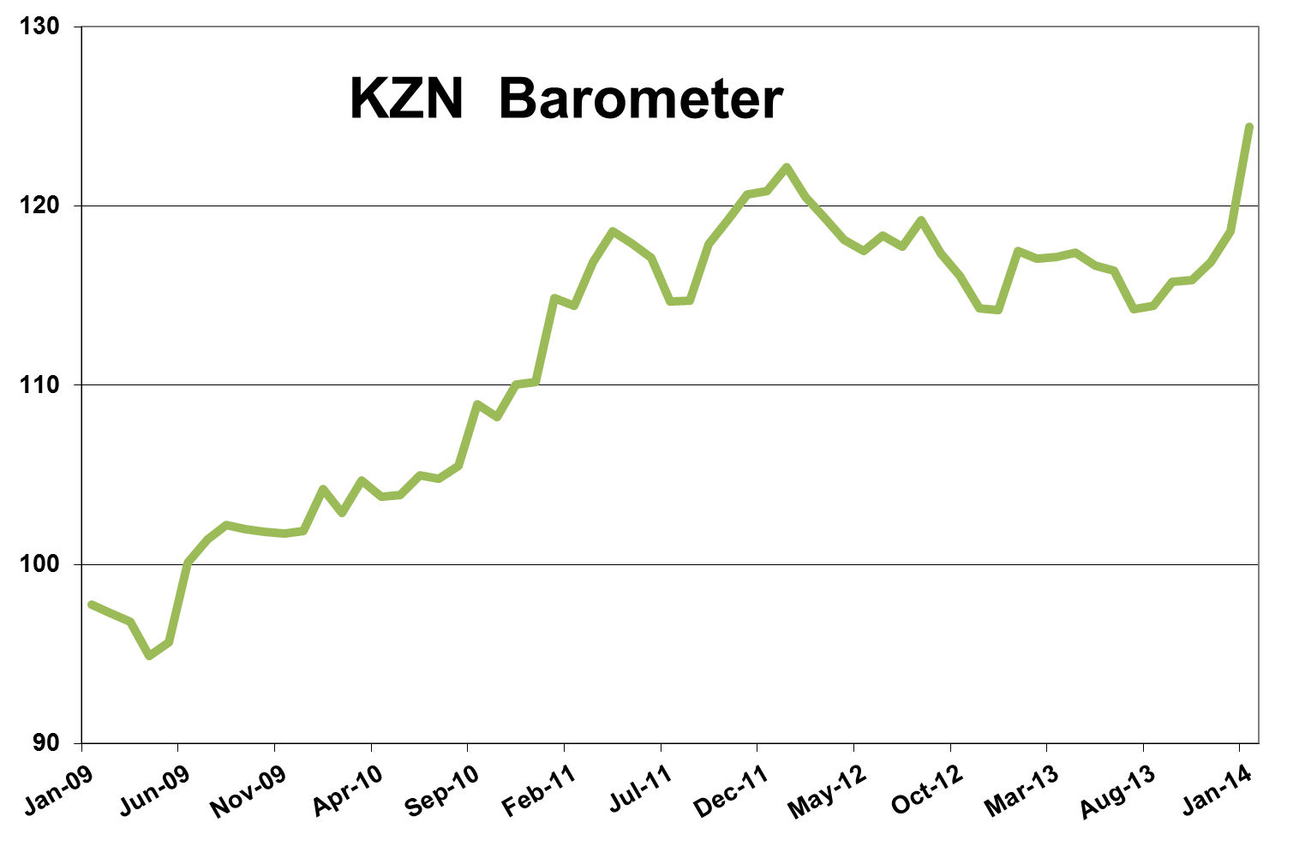
Economic activity in KwaZulu-Natal unexpectedly bounced back in January despite hikes in the petrol price and inflation as some sectors of the economy showed strong growth and increased employment numbers led to a fall in economic stress. The latest KwaZulu-Natal barometer, as compiled by Mike Schssler of Economists.co.za, grew 5.9% year-on-year, the strongest growth in two years. Month-on-month the barometer was up 4.9%, quarter-on-quarter; it gained 7.4% and the index was 8.3% higher than its levels of three years ago.
Lower economic stress boosts barometer
While the 2.6% year-on-year growth in the economy, compared with 2% the month before, shows there definitely is some life in the province’s economy, the main driver of the jump in the overall barometer was the fall in the economic stress index. The stress index, which measures negative factors like inflation, interest rates and unemployment, was down 3% year-on-year and also declined on a month-on-month and quarter-on-quarter basis. This was due to a 20.2% drop in civil debt cases and the provincial unemployment rate dropping to a two-year low. The decline in the stress index is, however, not expected to last, as inflation in KwaZulu-Natal is on the rise and almost touched the upper end of the Reserve Bank’s inflation target at 5.9%. The interest rate increase late in January will also reflect in the next barometer and will mean higher economic stress.
Agriculture performed well
Agriculture in KwaZulu-Natal continues to be one of the strong performers and helped to drive growth in the province, even though the sector only contributes about 4.7% to the province’s economy. The agriculture index was up 3.6% year-on-year as field crops and meat production increased. Month-on-month agriculture was up 1.2% and quarter-on-quarter it expanded 3.1%.
Mining reaches great heights
Mining, the other primary sector in the KwaZulu-Natal economy shot up by 14% year-on-year in much the same fashion as it did two months before. The sharp increase was mainly due to an increase in the production of building materials that are mined, and also in other non-metallic minerals. Coal production, which accounts for 72% of the KwaZulu-Natal mining sector, was down 10% on a year ago.
Construction disappoints
Although the increase in the production of building materials from mines would indicate that there are some big construction projects happening in KwaZulu-Natal, these projects are not yet reflected in the provincial construction index. The construction index was again the worst performer in the KwaZulu-Natal barometer and was down 11.1% year-on-year. Aside from a small increase in December 2012, the index has now been negative every month since March 2012. Buildings completed were down 18.1% year-on-year, but the 9.9% growth in lumber sales showed there were still some informal building projects and renovations taking place in the province.
Poor performance for manufacturing
Manufacturing in KwaZulu-Natal, just like in the rest of South Africa, is still struggling to recover despite the weaker rand which should, in theory, boost the sector’s export competitiveness. The manufacturing index was down 1.5% year-on-year, the fourth consecutive month of decline. While the closure of factories over the holiday season is a normal seasonal occurrence, the productivity in many sectors dropped more than usual for December. The only categories which showed real growth were textiles, clothing and footwear, radio and television equipment. The latter was most likely because of the Christmas season where people buy such electronics as gifts or for themselves.
High month-on-month growth for electricity
Despite the sharp increase in mining, which is an electricity intensive sector, the KwaZulu-Natal electricity index was down for the first time in nine months. While the index was down 0.1% year-on-year, it grew 12% month-on-month and 10.1% quarter-on-quarter. The increases in electricity usage in previous months were most likely due to certain big projects in the province. The month-on-month and quarter-on-quarter growth shows some of these are still happening and will at some point start to reflect in sectors like construction.
Transport and communication impress
After mining, the transport and communication index was the second-best performer in KwaZulu-Natal and was up 8.5% on a year ago. This was mainly due to an 18.3% increase in communications, slightly less than the previous four months’ increases, and growth of 4.7% in the volume of cargo handled by the province’s two ports. The main driver of growth in the ports was again Durban, where cargo volumes shot up by 30.5%. Airport arrivals were down 2.3%, the 23rd consecutive month of decline, but also the smallest decline in 22 months. The slower decline in passenger arrivals was likely driven by foreigners, who find the rand at its current levels cheap and thus see South Africa as a very competitively priced holiday destination.
Trade growth up
The woes of consumers in the current economic environment are clearly visible in the trade sector. The KwaZulu-Natal trade index grew 4.5% year-on-year, but retail sales, which usually boom in December and January, grew only 1.6%. Consumers are struggling and can’t really afford the things they used to during the festive season. The people who really suffer are the retailers as they have to cut their margins very thin and sit with large volumes of stock, as reflected by the 7.3% growth in wholesale. Vehicle sales grew 11.1% despite the lack of consumer and business confidence in the economy.
Finance, real estate and business services not performing as expected
The KwaZulu-Natal finance, real estate and business services index had its worst month in more than a year and grew only 0.6% year-on-year. This is partly due to the ongoing uncertainty in the South African economy caused by strikes, which affects investment. The 20.2% fall in civil debt cases, while reducing economic stress, also meant less work for lawyers, which contributed to the index’s bad performance. Property transfers also fell, by 4.4%, and mortgages were down 0.1% as the housing market faced some new difficulties amid the uncertainty.
Government spending strong before end of fiscal year and elections
Spending by the three tiers of government grew by its strongest pace in 17 months as it was up 4.8% year-on-year. Month-on-month it grew 6.3% and quarter-on-quarter the index gained 8.7%. The increase in government spending makes sense at this time of the year as especially municipalities and provincial governments try to spend the remainder of their allocated budgets to prevent their budget being cut in the next fiscal year due to underspending. The government’s fiscal year ends on March 31. The elections on May 7 could also be a driver of government spending in some cases.

Results Table: January 2014

