
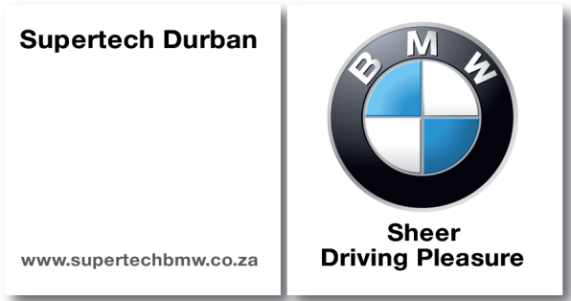

WELCOME TO THE SUPERTECH DURBAN KZN TOP BUSINESS AWARDS 2014
The Supertech Durban KZN Top Business Awards continue to be a highlight of the KwaZulu-Natal business calendar.

The Awards celebrate successful companies and organisations in KwaZulu-Natal. They offer an excellent opportunity for all business sectors to meet, be inspired and showcase their achievements and innovations to their peers.

Each of the Awards on offer celebrates and recognises business and organisational success across the economic sectors in both the private and public arenas.

All finalists will be entitled to two free tickets to the gala event where they will receive due recognition of their success, as well as coverage in the local media.

WHY ENTER?
Nominees receive publicity and recognition of their achievements throughout KwaZulu-Natal and beyond through the KZN Top Business website and e- newsletters.
Finalists receive media recognition after the Awards.
Winners receive a certificate and a trophy.
Winners also receive the accolade of being judged the best of the best in their field in KwaZulu-Natal.
In addition:
The Awards provide a great opportunity to boost team morale and reward staff for their contributions to your company/organisation.
You are able to raise your profile to customers and potential investors.
Finalists and winners will have their name and company profile appear on the KwaZulu-Natal Top Business website for 12 months after the Awards Ceremony – therefore 12 months worth of free advertising.

TERMS AND CONDITIONS
The Supertech Durban KZN Top Business Awards are open to all private sector companies and public sector agencies including government departments, municipalities and state owned corporations.
The company/organisation must have an office in KwaZulu-Natal.
Businesses may nominate themselves. Please see separate nomination form.
Decisions by the judging panel are final and no correspondence will be entered into.
All entrants must complete the entry form.

CRITERIA
The Supertech Durban KZN Top Business Awards’ criteria have been drawn from the principles of the King Report on Corporate Governance 2009 (King III) which replaced the King II Code and Report on Corporate Governance on 1 March 2010.

In line with King III, the Supertech Durban KZN Top Business Awards focus on the impact of the organisation/company in the economic, environmental and social spheres in KwaZulu-Natal. Factors such as brand and reputation, stakeholder relations and goodwill, environmental sustainability, social responsibility, and quality of governance are all taken into account.

King III applies to all South African entities, regardless of the form of the incorporation or whether it is in the public, private or non-profit sectors.

The exception is the Top Brand Award which is awarded on the basis of line public voting only (See website for more information).

CATEGORIES
An award is given in each of the following categories:
1. Agriculture: Incorporates establishments and activities that are primarily engaged in farming activities, but also includes establishments focusing on commercial hunting and game propagation and forestry, logging and fishing.
2. Mining: Includes the extracting, beneficiating of minerals occurring naturally, including solids, liquids and crude petroleum and gases. It also includes underground and surface mines, quarries and the operation of oil and gas wells and all supplemental activities for dressing and beneficiating for ores and other crude materials.
3. Manufacturing: Broadly defined as the physical or chemical transformation of materials or compounds into new products.

4. Utilities (generally referred to as “electricity”) : Includes the supply of electricity, gas and hot water, the production, collection and distribution of electricity, the manufacture of gas and distribution of gaseous fuels through mains, supply of steam and hot water, and the collection, purification and distribution of water.
5. Construction: Includes the site preparation, building of complete constructions or parts thereof, civil engineering, building installation, building completion and the renting of construction or demolition equipment with operators.
6. Trade: Wholesale and commission trade; retail trade; repair of personal household goods; sale, maintenance and repair of motor vehicles and motor cycles.
7. Transport, storage and communication: Transport as an economic sector refers to activities concerned with land transport, railway transport, water transport, and transport via pipelines, air transport, and activities of travel agencies, post and telecommunications, courier activities, as well as storage and warehousing activities.
8. Financial and business services: Includes financial intermediation; insurance and pension funding; real estate activities; renting or transport equipment; computer and related activities; research and development; legal; accounting; bookkeeping and auditing activities; architectural, engineering and other technical activities; and business activities not classified elsewhere.
9. Social and community services: Includes public administration and defence activities, activities of government, government departments and agencies; education, public and private; health and social work; sewage and refuge disposal, sanitation and similar activities; activities of membership organisations; recreational, cultural and sporting activities; and personal services e.g. hairdressing
10. Tourism: Encompasses many different economic activities under one heading. In terms of economic analysis, the tourism sector is distinctive in that it is not a sector formally classified as such in terms of the Standard Industrial Classifications. In light of the large contribution made by this industry to the KZN economy it has been decided to create its own category.
11. Municipal: Most proactive district municipality based on a current and active project success in promoting socio economic growth in its region.
12. Government: Most proactive KZN government department based on a current project’s success in promoting socio economic growth in the province
13. Partnership award (Blue chip award) : The winning project will reflect the importance of effective inter-agency collaboration and partnerships.
14. Top Brand Award (See website for more information).

SCORING
Scores will be given through an analysis of each company’s entry submission and followed up by interviews with key personnel where necessary to avoid misinterpretation or fill in gaps in information provided. Final points will be awarded through round table discussions with Supertech Durban KZN Top Business Awards’ board members.
Presentation of the company’s submission is taken into account in the scoring process.
Please note that the Top Brand Award is awarded on the basis of on line public voting only.

AWARDS EVENING
The decision of the judging panel will be announced at a gala dinner to be held on the 26 August 2014. To be eligible to receive an Award, company representatives must attend the dinner.

JUDGES
The award recipient(s) shall be selected by the judging panel. The panel will consist of representatives of industry and business. It is imperative to note that due to the range of organisations/ companies each is judged according to its own efforts and accomplishments within the appropriate sector.

AUDITING
Morar Incorporated has been appointed to audit the results.

ENTRIES
Entries must be submitted to gayle@topbusiness.co.za
Final entry date: 15 August 2014
Queries: 031 2671977

