BETI Report

Mike Schüssler

Oct 2014

A decline that may just be a turning point – BankservAfrica Index
While a smaller decline is certainly a massive improvement for the South African economy, the BETI shows that the economy is still fragile. The whole third quarter shows a decline over the second quarter of 2014. However, this does not mean that the economy is back in negative territory. Rather, the economic growth will remain weak and probably at levels of around 1%.
The year-on-year decline eased from -3.2% to -1.4%, an indication of how fragile the economy still is. The BETI indicates that the economy is getting back onto its feet and may just start to crawl along again soon. It is perhaps the only time that the change has been so big that a much smaller decline could be indicating a turning point for the South African economy.
While the data still indicates a decline after taking the effect of inflation into account, the fact that the decline has more than halved shows that the economy is eager to get back to growth, albeit slowly. This point proves that, despite ongoing post office strikes and NEASA lockouts, the economy is showing signs of life rather than decline.
The South African economy is no longer declining and we can be hopeful of increased activity in the next couple of months. Although South Africa’s strike-prone economy received a small boost from less strike activity, there is still industrial action that makes a business-as-usual outcome unlikely. Nonetheless, industrial action is now just a fraction from the February to July period, which will somewhat facilitate a recovery.
Also helping the economy in September was a significant drop in petrol prices, which will also, in turn, help consumers to recover slightly. With wage increases somewhat above inflation, the economy will also benefit. Furthermore, better export earnings from the motor as well as tourism industries are partly offsetting the decline in commodity prices.
Overall, exports are recovering to some extent from the massive strikes, which will also help stabilise the economy. One can also expect that tourism numbers during the summer months may have a positive impact, since overall tourism numbers are still increasing.
Car sales increased by 11% in September, but were largely driven by rental and industry sales rather than consumer sales. Although the PMI also swung into positive territory, the bounce-back is by no means strong enough to drag manufacturing out of its current soft phase.
The month-on-month change in the BETI was flat, and at -0.1% change in August the end of the downward phase is probably closer (but not necessarily certain). September will more likely be remembered for bringing a sense of calmness after the storm rather than growth.
Tracking the BETI over the last few months has shown the fragile nature of the economy which is widely felt at present. However, the uncertainty also became apparent over the last few months as the BETI showed consumer and business confidence were weak this translated into uncertain growth projections.
From the last two years it seems to become clear that the economy needs more attention as economic transactions only take place when based on a solid and certain footing.
After a weak BETI in August, September showed an improvement in the slowing decline. The economy can no longer take the kind of damage that has been going on for so long. South Africa will automatically see growth with less strike action that destroys the productive sectors.
The BETI still represents the quickest and broadest tracking tool for the South African economy. The fact that it is still negative is concerning. However, the rate of decline has diminished itself to such an extent that the numbers indicate a more upbeat trend.
This trend is not certain, but the chances that the economy may bounce back in the fourth quarter of 2014 are improved.
The transaction numbers
The total number of transactions used in the BETI increased by 7.4% on a year-ago basis to 85.5 million, the highest number ever. When taking into account that September 2014 had 21 week days, the increase is meaningful. This is the strongest increase in the number of transactions since July 2013 and certainly indicates that economic activity is spreading and once again growing.
One should also remember that the biggest part of September did not have the small increase in the rate of interest that the South African Reserve Bank implemented late in the month.
The total value of the transactions was R660 billion – an increase of 8.6% in nominal terms, which was above the estimated inflation rate. The average value of transactions increased by only 1.2% from a year ago to R7727. Again these raw numbers also indicate that average transaction values are not increasing in real terms at all. Although the weaker economic conditions in the economy have had an effect, the overall trend seems to indicate that smaller items are still being sought and that durable and expensive items are still off the radar of the participants in the SA economy.
The standardised BETI, after taking the number of workdays into account, was R673.6 billion, which was also up with 8.6% in nominal terms. The deflator used was 6.5% and is a combination of both consumer and producer price changes.
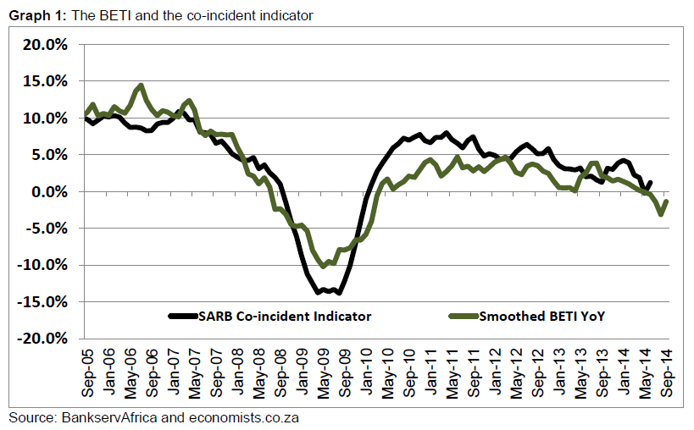



South Africans try to pay off debt as cash crunch continues – BankservAfrica Index
The average South African's disposable income has declined for the first time since January, while de-population of the ranks of the lower middle class continued over the past three months. This is according to the latest BankservAfrica Disposable Salary Index (BDSI).
According to Michael Rubenstein, head of corporate reputation at BankservAfrica, 2014 has had two negative months of take-home pay so far.
The average disposable salary came in at R12 224 in August. While slightly lower than July, it remains 6.1% up on a year ago.
With inflation at 6.4% in August, Rubenstein says the actual salaries are weaker after the catch-up of pay increases from general government and state-owned enterprises. "The BDSI shows that real salary increases are once again becoming constrained."

Tighten the belts even more
Mike Schüssler, chief economist at economists.co.za, says the BDSI indicates retail sales may in the next month or two, be lower than July.
"The formal sector employee is less likely to afford as many or as expensive new cars as before. Wages may be increasing, but are not going to increase at the same rate as before," he says.
According to Schüssler, the total value of salaries (including pensions and ultra-high income individuals) saw an increase of just over 7% to R44.8 billion.
"This, along with credit data, suggests that South Africans are not increasing their debt levels and are rather concentrating on paying the debt back. Confidence in low interest rates is also probably declining. In addition, the financial sector has become more careful in granting loans to the lower end of the market."

More people get more, but fewer blue-collar salaries
The number of people receiving between R50 000 and R100 000 in disposable income per month, grew by 24.5% year-on-year. The next highest category (between R25 000 and R50 000) grew by over 18%.
Those receiving less than R4 000 in their bank account grew by 10.8%, but the largest category, those earning between R4 000 and R 10 000, again declined by nearly 2.5% year-on-year.
Schüssler says an interesting fact is that the number of people earning between R4 000 and R10 000 per month now makes up 42.6% of the total, while those earning between R10 000 and R25 000 currently makes up 35.3% of the sample in the BDSI.
The category of those who earn between R25 000 and R50 000 is estimated to be 8.1%. Those taking home over R50 000 and up to R100 000 make up 1.5% of the total BDSI.
The lowest income category, namely those earning below R4 000, now reflects just over 13% of the estimated number of people in the BDSI. This means that more than 55% of South Africa's working population, as reflected by the BDSI, earn less than R10 000 per month.
"More people are earning higher salaries, while the bottom end of the middle class – those earning between R4 000 and 10 000, is de-populating. It is also quite clear that the growth in the number of accounts receiving over R10 000 is growing in double digits."
Although the BDSI does not include individuals earning over R100 000, it is interesting to note that this category has grown by 27.2% in August, year-on-year. This category has now seen growth of over 37% for the first eight months of 2014, over the same eight months of 2013.
"The trend of more people entering the higher income brackets is partly due to above-inflation increases within these categories," Schüssler explains.

An interesting trend
A trend that needs further investigation over the next year is the decline in the number of employees earning between R4 000 and R10 000 as take-home pay, while categories above and below this range continue to see actual growth.
"However, the fact that the category including those with a take-home salary of over R10 000 has grown from 34% to 44% in less than two years must be an indication of wealth creation in the South African formal sector," Schüssler concluded.


