KwaZulu-Natal Business Barometer

September 2014

KwaZulu-Natal Barometer dragged down by factories and finance
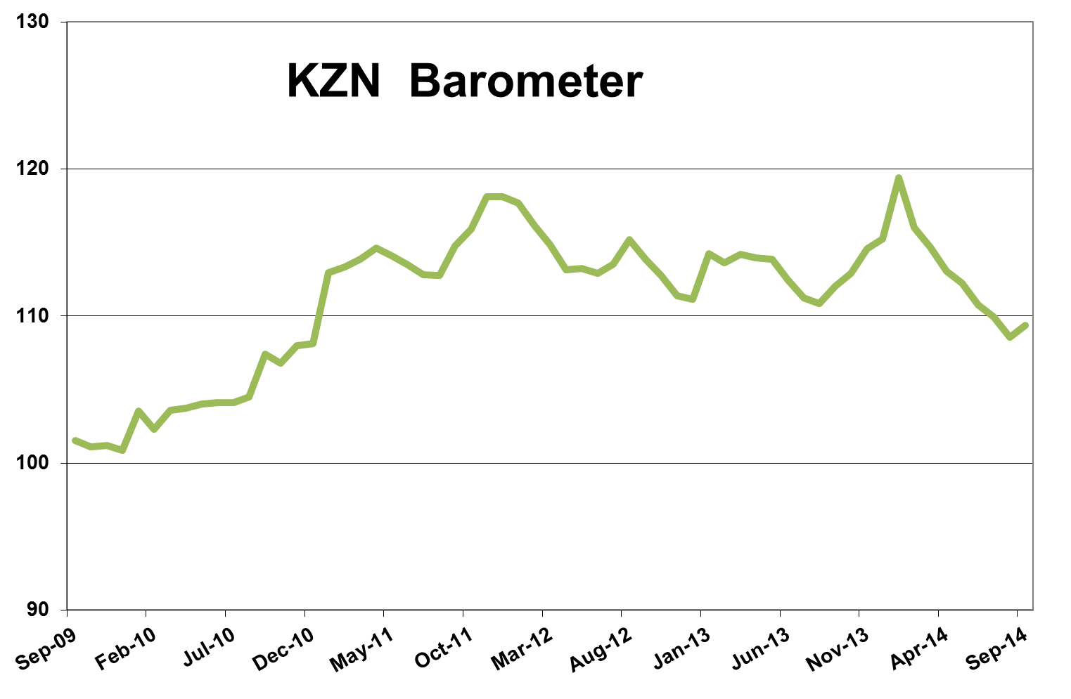
KwaZulu-Natal's economy is under strain due to a lack of growth in the two biggest sectors, manufacturing and finance, showing that the economic slump is still broad-based. The latest KwaZulu-Natal barometer, as compiled by Mike Schüssler of Economists.co.za, declined 2.4% year-on-year, the most in 13 months, as increased economic stress eroded the effect of the little growth the economy has shown.

Economic stress on the rise
The growth index was up 3.3% year-on-year, 1.3% month-on-month and 2.3% on a quarter ago, boosted by transport and communications in particular. Given these growth numbers, the KwaZulu-Natal barometer could have been very positive if it was not for the increase in economic stress. The stress index, which reflects factors like unemployment, inflation and interest rates, was up 5.8% on a year ago, the most since last August, and also grew on a month-on-month and quarter-on-quarter basis. Compared with three years ago, economic stress is 10.8% higher. Growth in KwaZulu-Natal could run into serious problems if the stress index continues to grow like this. The increase in the stress index was driven by the rise in unemployment to 24.1%. While inflation in the province has come down slightly to 6.2% from 6.3%, it is still outside the Reserve Bank's 3% to 6% target range and after the 75 basis points of interest rate increases this year, the borrowing cost is higher than 12 months ago.

Agriculture grew slightly
With a contribution of 4.7%, agriculture is one of the smaller sectors in the KwaZulu-Natal economy. The agriculture index grew 2.7% year-on-year and despite the relatively small size of the sector, the month-on-month and quarter-on-quarter declines in the index was somewhat worrying and points to a likely slowdown or even decline in the year-on-year numbers in the near future. The shorter term declines are probably due to the drought in the province, the effect of which will be exacerbated in coming months.

Mining shows minor decrease
The KwaZulu-Natal mining index, which consist 72% of coal, declined by 0.9% year-on-year, 1.5% month-on-month and 1.6% quarter-on-quarter. This was due to a drop in coal production and the output of other non-metallic minerals. The mining of building materials, which contribute 22% to mining in the province, increased by 2.6% even as the construction sector is still struggling.

Manufacturing disappoints
Manufacturing in KwaZulu-Natal also continued to decline in line with the weak economy and the index was down 3.7% on a year earlier. The only real ray of light in factory sector was the 32% increase in the production of motor vehicles and parts. This growth, however, comes from a low base which was created when vehicle plants shut between August and October last year due a strike, resulting in a huge drop in output of vehicles and parts. Furniture production grew by 4%.

Electricity fell in face of mining and manufacturing deterioration
The electricity index declined by 4.8%, the biggest year-on-year drop in 24 months, and also decreased on a monthly and quarterly basis, indicating a drop in electricity usage. This is probably due to the continued declines in the big energy intensive sectors, mining and manufacturing. The drop in output at mines and factories is also dragging down other sectors in the economy, which results in even less power usage. This is besides the fact that increasing electricity prices curbs demand. The recent round of load shedding following the collapse of the coal silo at the Majuba power station will result in even more decreased electricity usage countrywide.

Construction in downward slope
The KwaZulu-Natal construction index decreased by 7.9% year-on-year, 1.3% month-on-month and 3% quarter-on-quarter. The index is also still 21.9% down from its levels of three years ago, reflecting a broad lack of recovery. Buildings completed have been in decline since early in 2012 and decreased 19.4% in September after sharp drops in the completion of non-residential buildings, like shopping centres and warehouse space. This reflects a continued lack of business confidence. Lumber sales, which grew in double digits earlier in the year, increased by only 1.8%, showing that even informal building and additions are not happening as much as before.

Transport and communications surprises with double-digit growth
The one big positive in the KwaZulu-Natal barometer was the transport and communications index, which increased by 23.9% year-on-year and was also up on a month-on-month and quarter-on-quarter basis. Communications increased by 46.4% after a 204% surge in the web impressions on local browsers. A recent report by PwC said the increase in internet usage is due to consumers' changing views and expectations and increased internet access will generate more consumer spend than any other media in the next five years. South Africa's internet revenue could reach R71.6 million a year by 2018, the report said.
While communication was the main variable in the index for the month, passenger arrivals at the King Shaka International Airports increased by 1.3% year-on-year, the second month of growth after more than two years of decline. This recovery is passenger arrivals in KwaZulu-Natal could, however, be threatened by the current Ebola outbreak in West-Africa, which could make tourists and business people more averse to visiting South Africa as a whole, a risk flagged by the World Bank in a report early in November.

Trade index weakens
The KwaZulu-Natal trade index increased by 3.5% year-on-year and while this looks promising, the trade didn't grow at all on a month-on-month basis and was down 0.6% on the previous quarter, pointing to a weakening index. The year-on-year growth was driven by an 8.4% increase in retail sales, even as consumers are still struggling. Petrol sales declined 3.9% year-on-year, the 14th consecutive month of decline, as fuel prices remained close to record-highs in July and August. The recent drop in the oil price and the rand's strengthening had already led to a drop in the petrol price and might support sales in coming months.

Finance, real estate and business services index in a slump
The finance, real estate and business services index, which accounts for 19.6% of the provincial economy, has been disappointing since the start of the year. The index declined by 5.3% year-on-year in September, driven by a 7.5% decline in advertising and a 5.4% decrease in mortgages. Civil debt cases dropped by 39% from a year earlier, and while this means less economic stress, it also means less work for lawyers, which was a further drag on the finance index.

Government spending on the up
Spending by the national, provincial and local levels of government in KwaZulu-Natal increased by 6.9% year-on-year, 2.2% month-on-month and 3.9% quarter-on-quarter. The growth in government spending is at reasonable levels and in line with what the National Treasury said spending should grow by. If it was not for the huge increases in the stress index, the positive effect of government spending would have been much more visible in the KwaZulu-Natal barometer.

Results Table: September 2014

