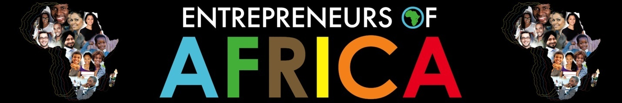

Africa Day Concert on Saturday the 23rd of May at the Durban ICC at 6pm.

The African Renaissance Festival and Conference will host the annual Africa Renaissance Concert on Saturday the 23rd of May at the Durban ICC at 6pm.

Now in its 17th year, the annual African Renaissance Festival is a celebration of progress and opportunity on the African continent. The concert is a highlight event of the festival programme and is a cultural showcase featuring an eclectic mix of superb artists that will entertain everyone in the audience. These include DJ Sgqemeza, the KZN Philharmonic Orchestra in collaboration with Sfiso Ncwane; Toya Delazy and Donald.

Sfiso Ncwane, who has been voted as the most influential young person in KZN and South Africa( Ugu Youth Awards 2011). He is not only an artist, but he truly exemplifies a role model to whom one can aspire. Through his music and talent, Ncwane has brought gospel music to the youth, making it relevant to local as well as international fans. The singer, drummer and bass guitarist was named as the most idolized artist in South Africa by the Drum Darling Awards (2013). Other achievements in 2013 included the best male gospel award, best gospel song and best gospel artist in South Africa at the AGMA awards in London. In addition, in the same year Ncwane was also the first ever gospel artist to win the SAMA song of the year award.

The acclaimed Durban based KZN Philharmonic Orchestra, which is widely regarded as ‘Africa’s premier orchestra’, will be performing with Sfiso Ncwane. This event will provide an excellent platform to show off the KZN Philharmonic’s vast repertoire.

Latoya Nontokozo Buthelezi aka Toya Delazy is a musician hailing from eMhlabathini, KwaZulu-Natal South Africa. With two albums to her title “Due Drop” and “Ascension”, she has already proven herself both locally and internationally as a force to be reckoned with. Her music has been called a mixture of jazz, electro and hip-hop, with a healthy South African
flavour. Her musical influences include acts such as Asa, Nirvana, Adele and Radiohead to name a few. Toya holds three SAMAs to her name. She has also been nominated for numerous awards including the Best International Act at the BET awards.

Chart topping and multiple award recording artist Donald Moatshe, or Donald as he is popularly known to his fans will don the stage with aplomb. Donald is an artist who brings with him refreshing music coupled with a clean image and an abundant singing and writing talent. In 2014 Donald released his most anticipated album “ Black and White”. The album debuted at number three on iTunes and number five at Musica Stores. The music videos “Crazy But Amazing” and “Unpredictable” were some of the most played videos on Channel O and TraceTV.

At just over 34 years of age, DJ Sgqemeza is one of the record breakers on radio and is the host of the VukaMzansi Breakfast Show on Ukhozi FM. Sgqemeza is also the brand ambassador for KwaZulu-Natal Liquor Authority, motivating youth regarding alcohol abuse and teenage drinking.

The concert will start at 6pm until late at the Durban ICC Arena and tickets are R115 and are available from Computicket.

Media Enquiries
Gayle McLennan-Smith
031 2671977
083 6530465
gayle@topbusiness.co.za

