Service delivery protests barometer 2: Provincial distribution of protests per year
This Barometer measures the geographical distribution of protests by province. in 2012. The project seeks to collect and analyze data at the provincial level but also at the district and municipal levels. The provinces have generally followed the upward trends in protests seen in Barometer 1, with the exception of Gauteng, the only province to show a consistent downward trend since 2009.

Figure 5 compares total protests per province
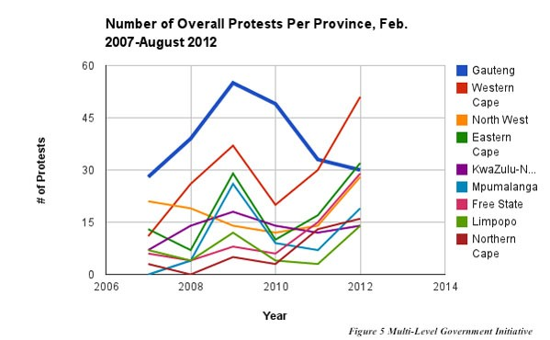
Key trends:
- Gauteng yielded the highest protest activity from 2007-2011 but then dropped significantly in 2012.
- As of August 2012, the Western Cape is the province with the highest number of protests.

Figure 6 compares percentages of protests occurring in each province
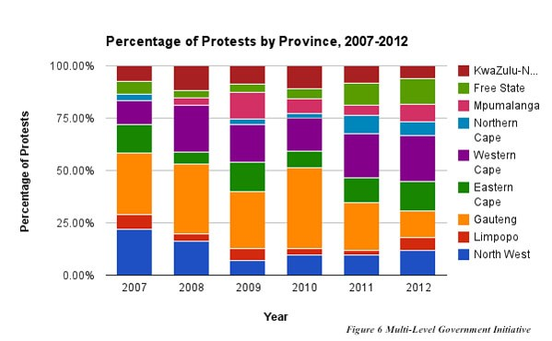
Key trends:
- Gauteng’s percentage of total protest activity has fallen in 2012, from 22.92% to 12.95%.
- Western Cape, Eastern Cape, and Gauteng account for 56.98% of all protests, more than all other provinces combined.

Figure 7 compares protest distribution within provinces
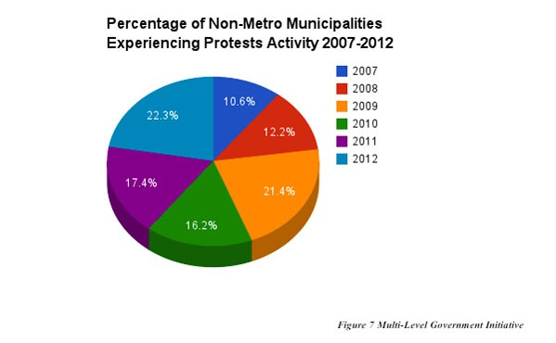
Key trends:
- Protests are not limited to metro municipalities, the percentage of non-metro municipalities experiencing protests has increased from 10.6% to 22.3% since 2007

Figure 8 compares annual protest levels in metro and non-metro municipalities
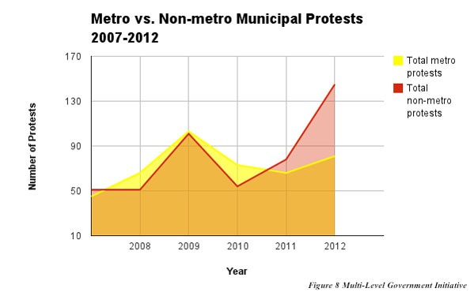
Key trends:
- As of 2011, protests are more likely to occur in non-metro municipalities than in metros.
- Protests are spreading throughout non-metro municipalities, reaching a 6-year high in winter 2012.

General analysis
Figure 5 above reflects yearly protest figures in each of the 9 provinces. For the first time in the 5 year dataset, Gauteng has not had the most protests, having been surpassed by both the Western and Eastern Cape provinces. Gauteng’s percentage of total protest activity has fall by almost half (from 22.92% to 12.95%) in 2012. The Western Cape now leads the provinces in protests for 2012, with 49. Alone, the top 3 provinces account for over half (56.98%) of all protests, more than all other provinces combined. Prior to 2012, Western Cape recorded its highest protest activity during election years, in 2009 and 2011. Map representations show that protest activity is not confined to metro municipalities but is also increasingly present in rural areas.

