Message from Mark Taylor
It has been a very busy past few weeks, with a whole lot of activity taking place. Firstly, I would like to mention the success of the eLan Gold Cup at Greyville Racecourse. A big ‘thank you’ goes out to all who attended and to those who were involved in the planning and execution of the event.
As some of you may have heard, on the 27th of July 2015, the leading Asian hospitality group, Dusit International entered into an exclusive agreement with eLan Property Group to manage several hotels and resorts in Southern Africa and Indian Ocean region. Dusit signed agreements on 5 hotels, potentially looking at Franschhoek, 3 hotels at Blythedale Coastal Resort and in Mauritius. I am very excited about this relationship mainly because of their experience in hospitality training. They have close to 20,000 students within Asia currently undergoing training in hospitality.



  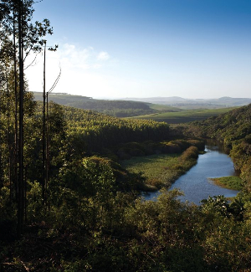
  Blythedale Coastal Resort Teaser Video
  Take in the beauty of Blythedale from above including a thousand hectares of tranquil forest, rivers and estuaries; all set alongside a three kilometre stretch of untouched ocean frontage.
  



eLan Property Group brings back the style at the
prestigious eLan Gold Cup


As most of you may have heard or even attended, eLan Property Group brought back the style at the prestigious eLan Gold Cup hosted at Greyville Racecourse. The original date set for the eLan Gold Cup was the 25th of July but due to bad weather conditions in Durban over that weekend, the event was postponed to the 1st of August. Nonetheless, all who attended had a fun day full of entertainment with VIP lounges, great balcony views of Durban Skyline, live entertainment throughout the day and a whole lot more.

  
  Blythedale Coastal Resort
  Update - August 2015
  Time is ticking… With only 65 days left before the anticipated world launch of Blythedale Coastal Resort on October, 28th 2015 in London, Dubai, Johannesburg and Durban (Greyville Convention Centre). We are jovial to see the high interest in the general public as people are registering their interest daily.
  

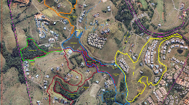

Take a look at our brand new Simbithi Eco Estate Interactive Map


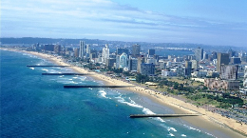

KZN property market making a steady recovery

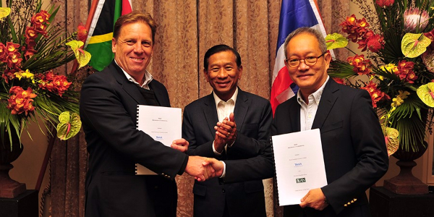

eLan Property Group and Dusit International form Historic Partnership
Dusit International, a leading Asian hospitality group, has entered into an agreement with eLan Property Group to manage several hotels and resorts in Southern Africa and the Indian Ocean region. The agreement was signed at L'Ermitage in Franschhoek on July 26 2015.


eLan is proud to be giving back to Sports Development in South Africa. Have a look at our latest initiatives



Property Investors now betting on Student Accommodation


The Best Way to Market your Property Online

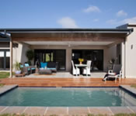
4 Bedroom House For Sale in Simbithi Eco Estate
R5 500 000
 | 4 |  | 3 |  | 2



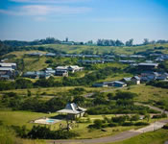
1 616 m² Vacant land / plot for sale in Simbithi Eco Estate
R3 850 000
 | 0 |  | 0 |  | 0

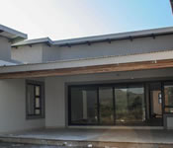
4 bedroom house in Palm Lakes Estate
R3 000 000
 | 4 |  | 2 |  | 2



Upgrade to Platinum Membership
Platinum Membership is given exclusively by invitation or to succesful applicants. Please feel free to contact our team on the details below to find out how to upgrade.
www.elan.co.za/investor-club

(031) 576 9600

