Follow this link to view a web version of this message
This is a Durban Chamber of Commerce and Industry in Partnership
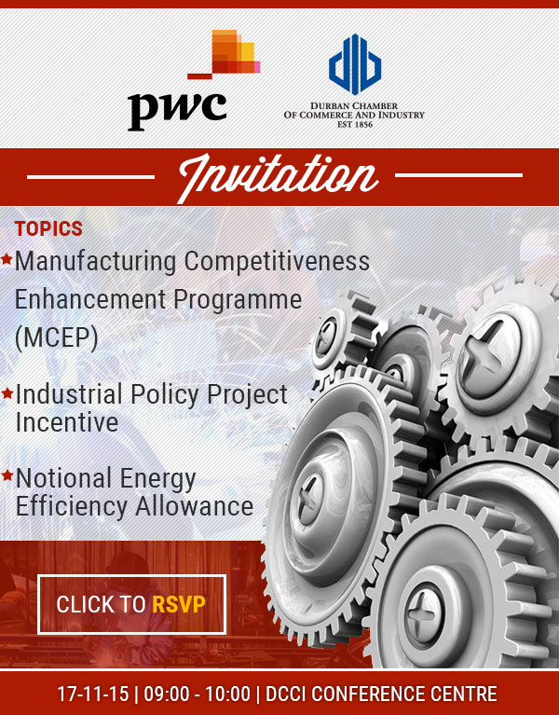
Dear Member
The Durban Chamber of Commerce and Industry and PwC welcome you to join us in discussions regarding government incentives in the non-automotive manufacturing space. We will discuss recent changes to the Manufacturing Competitiveness Enhancement Programme (MCEP), the Industrial Policy Project Incentive and the Notional Energy Efficiency Allowance.
17-11-15 | 09:00 - 10:00am
Dress:
Business attire
Venue:
Durban Chamber of Commerce and Industry Conference Centre
Chamber Square, Lion Match Office Park, 892 Umgeni Road
Click here to view Chamber parking for visitors
NB: For enquires please contact Nomthandazo Mchunu - 031 335 1000
RSVP is essential for access control and parking
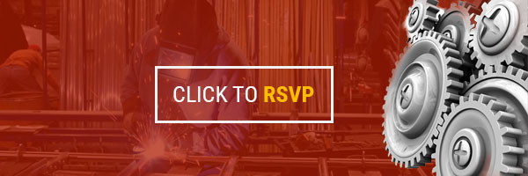

You are receiving this email because you have an association with the Durban Chamber of Commerce. Your company is or was either a member, or subscribed to our mailing list(s) at some point. We hope you found this message to be useful. However, if you'd rather not receive future emails like this from us, it's easy to unsubscribe by following the link below. You also have the ability to review other mailing lists available, and subscribe or unsubscribe accordingly.

