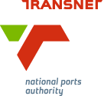
MEDIA RELEASE

Launch of TNPA Tug Shows Operation Phakisa in Action
[Durban, South Africa, 12/11/2015] Transnet National Ports Authority celebrated a milestone in its R1.4 billion tug building contract this morning when the first of its nine new, powerful tugboats was ceremonially launched at the Durban premises of contractor, Southern African Shipyards.

“This is the largest single contract TNPA has ever awarded to a South African company for the building of harbour craft,” said TNPA chief executive, Richard Vallihu.

In line with maritime tradition, the duty of officially naming the vessel was carried out by a Lady Sponsor, Lauriette Sesoko, General Manager: Commercial and Marketing, of TNPA. The tug was named ‘MVEZO’ in reference to the small village in the Eastern Cape of South Africa where former President, the late Nelson Mandela, was born.

“The building of MVEZO and the eight other tugs in this project, demonstrates that this country has the expertise to compete in the global shipbuilding industry and to use the maritime economy to unlock the economic potential of South Africa, in line with the government’s Operation Phakisa initiative,” said Vallihu.

MVEZO is expected to be handed over to the Port of Port Elizabeth in February 2016, followed by handovers every three months until the last one is launched in early 2018.

Big Benefits

The tug building project kicked off in August 2014 and is providing a big boost to the local economy over its 42 month lifespan. Given the project’s tight deadlines five tugs are under construction simultaneously at any given time.

TNPA programme manager Eugene Rappetti, Senior Manager for Marine Operations, said TNPA had 29 tugs presently in service nationally, but the requirement for bigger, strong tugboat fleets had increased in line with bigger commercial vessels calling at South African ports more frequently.

“TNPA’s new fleet will include nine tugs that are 31 metres long with a 70 ton bollard pull. The older tugs have 32.5 to 40 ton pulls.

“The increased bollard pull of these new generation tugs meets international standards and they also feature the latest global technology. The tugs have Voith Scheider propulsion which makes them highly manoeuvrable and able to change the direction and thrust almost instantaneously while guiding large vessels safely into our ports,” he said.

Durban based Southern African Shipyards, which owns and operates the largest shipyard in Southern Africa, also built TNPA’s previous 12 tugs. The company scooped the latest contract through an open and transparent process. Its employees have a 12 percent stake in the company, which has 60 percent black ownership.

Subcontractors on the project include well-known multi-nationals such as Barloworld Equipment, Siemens, Voith Schneider, as well as local contractors such as Bradgary Marine Shopfitters.

CEO Maharaj said his company had created 500 direct and 3500 indirect jobs through the project. “We have also committed to ensuring that each tug has a minimum of 60% locally manufactured components, while partnering with international companies on the remaining aspects that cannot be manufactured here, for example the engines and propulsion units,” he said.

Maharaj said the intention was to maximise local content and spread the benefits of the project to black suppliers, women- and youth-owned businesses. Ultimately South Africa will achieve a socio-economic benefit of more than R800 million as a result of the Supplier Development Plan attached to the contract,” “he said.

In addition a number of national and international training and development opportunities are being created for local employees, with TNPA already set to send employees to Germany for training on the new propulsion units. They would also receive training locally for four to six weeks.

Rappetti said TNPA also had a large training programme in place for engineering and deck cadets to ensure that the vessels had skilled people in place to operate them.

This massive project will see two tugs each allocated to the Ports of Durban, Richards Bay and Port Elizabeth, while Saldanha, which handles the largest carriers, would receive three tugs.

Ends
Image Library:
Below: TNPA’s new MVEZO tug which was launched and named at the Southern African Shipyards premises in Durban, South Africa. Lady Sponsor, TNPA GM: Commercial & Marketing, Lauriette Sesoko, officially named the vessel, flanked by Charles Maher, Southern African Shipyards GM: Marketing.
Photos courtesy of Southern African Shipyards.

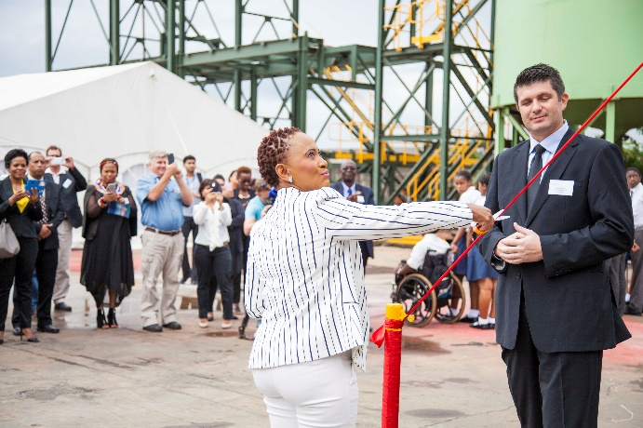
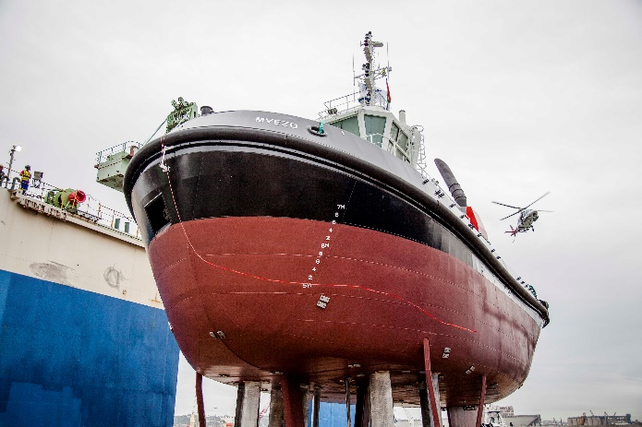
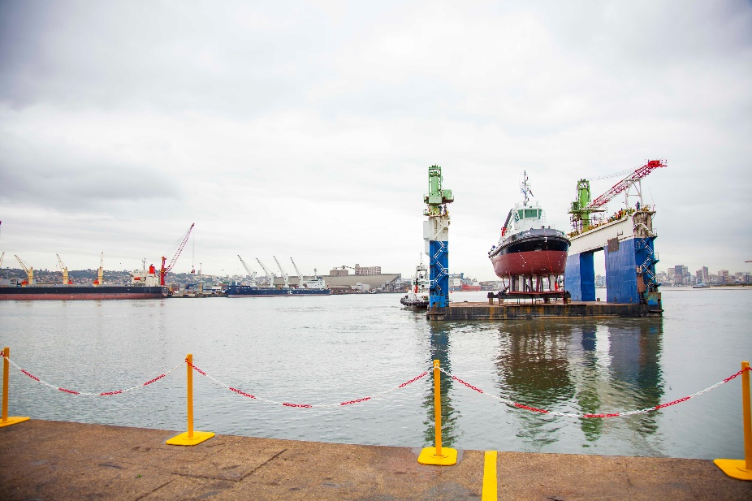

About Transnet National Ports Authority
Transnet National Ports Authority (TNPA) is one of five operating divisions of Transnet SOC Ltd. The National Ports Authority is responsible for the safe, effective and efficient economic functioning of the national port system, which it manages in a landlord capacity. It provides port infrastructure and marine services at the eight commercial seaports in South Africa – Richards Bay, Durban, Saldanha, Cape Town, Port Elizabeth, East London, Mossel Bay and Ngqura. It operates within a legislative and regulatory environment and is governed by the National Ports Act (Act No. 12 of 2005). For more information visit www.transnetnationalportsauthority.net.



Issued by:
Lunga Ngcobo
GM: Corporate Affairs
Transnet National Ports Authority
Tel: 011 351 9013
Lunga.Ngcobo@transnet.net

On behalf of:
Richard Vallihu
Chief Executive
Transnet National Ports Authority

For more info:
Eugene A Rappetti (MIMarEST)
Senior Manager Marine Operations
Chief Harbour Master
Tel: 031 361 8921
Cell: 083 357 3040
eugene.rappetti@transnet.net

Lucinda Hippolyte
Corporate Communications
Southern African Shipyards
Tel. +27 (0)31 274 1800
lucindah@sa-shipyards.co.za

