KwaZulu-Natal Business Barometer

December, 2011

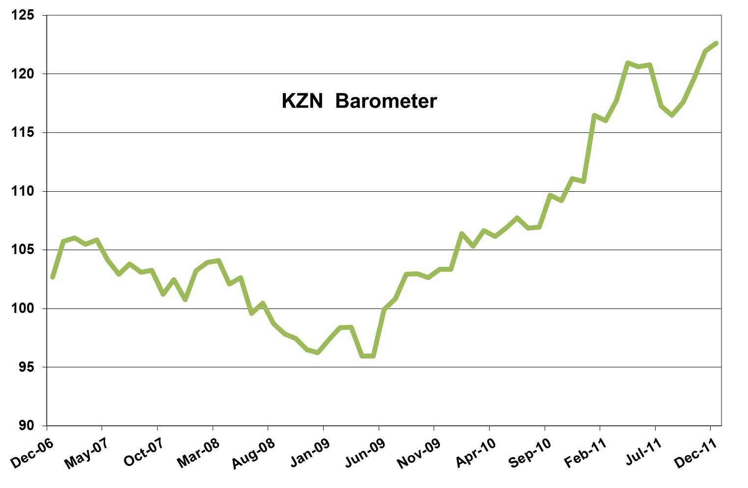
KZN economy continues to expand

The KwaZulu-Natal economy has been growing strongly for about 18 months and while growth may have slowed somewhat during the course of last year, the province’s economy continues to expand.
According to the latest KwaZulu-Natal barometer, as compiled by Mike Schüssler of Economists.co.za, KwaZulu-Natal’s economy grew by 6.5% year-on-year in December. This was substantially slower than the 12% growth achieved last April, but still adequate to help the overall KwaZulu-Natal barometer grew by 10.6% year-on-year, its strongest growth in six months. The barometer was also positive on a month-on-month and quarter-on-quarter basis and was 27.4% higher than three years ago.

Reduced stress boosts economy

The continued decline in economic stress in KwaZulu-Natal boosted the province’s barometer.
The economic stress index, which measures negative factors like inflation, interest rates and unemployment, has been negative for two-and-a-half years and declined by 3.7% year-on-year in December. Economic stress was 16.0% lower than in December 2008, at the height of the international financial crisis and the recession.
Employment growth in KwaZulu-Natal had a positive effect on economic stress levels. The unemployment rate in KwaZulu-Natal was 17.9% in December, compared to 20% last January. The latest national unemployment rate, as measured by Stats SA in the third quarter of last year, was 25%.
KwaZulu-Natal’s inflation rate of 6.6% was however marginally worse than the national inflation rate of 6.1%.

Government spending slowing

Government spending by the national, provincial and local governments in KwaZulu-Natal still grew by double-digits year-on-year in December, although the 11% growth was the lowest since last February. Government spending has turned negative on a month-on-month and year-on-year basis, as government started to spend less in the last quarter. Government reduced the accelerated pace at which they were spending early last year to build up some spending capacity in case the anticipated global economic slowdown strikes the province.

Transport and communication still on a high

The transport, storage and communication sector in KwaZulu-Natal, which contributes almost 14% to the province’s economy, continues to be one of the best performing sectors.
The KwaZulu-Natal transport index posted its 15th consecutive month of double-digit year-on-year growth and grew by 18.2%. The sector also grew on a month-on-month and quarter-on-quarter basis and was 36.9% up from three years ago.
The strong growth in this sector was partly thanks to the continued gravity-defying growth in internet usage. Countrywide page impressions on local browsers grew by around 30% year-on-year as data packages become increasingly cheaper and accessible for consumers.
Cargo handled at the ports of Durban and Richards Bay increased by 2.5% year-on-year. This was slower than the growth of more than 8% recorded earlier last year, but the slowdown was to be expected given the slower growth in the world economy.
Passenger arrivals at the King Shaka International Airport grew by 3.3% year-on-year and have now been growing for 27 consecutive months.
Land transport volumes grew by 10.9% year-on-year. Economic growth and demand in the rest of southern Africa play a big role in the land transport volumes of KwaZulu-Natal and other provinces. Many road freight trucks and trains are taking African freight through SA and a lot comes in through KwaZulu-Natal’s ports. South African firms are transporting their goods on trucks and trains directly to other African countries.

Manufacturing slowly making headway

The manufacturing sector in KwaZulu-Natal is doing exceptionally well compared to some of the other provinces, although the manufacturing index only grew by 3.5% year-on-year in December.
The manufacturing of food and beverages was up 8.4% from a year ago, which can partly be attributed to the apparent turnaround in the province’s agriculture. Wood and paper manufacturing, which accounts for 16% of the province’s manufacturing industry, was up 9.3% after recovering from strikes in the middle of last year.
The manufacturing of basic ferrous and non-ferrous metal products grew by nearly 6% after it also suffered during two strike-prone months in the middle of the year.
On the negative side, textile and clothing manufacturing suffered its 19th consecutive month of decline. Petroleum product manufacturing showed almost no growth due to pressure caused by refinery shutdowns. Vehicle manufacturing dropped by nearly 13% as export demand slowed due to the sluggish world economy.

Soaring electricity prices still limiting usage

Electricity supply constraints, which Eskom has warned about in the last two weeks, can have a major adverse effect on the manufacturing sector, especially the electrical machinery, machinery and metals, and petroleum industries. It could, however, have a slight positive effect for the wood and paper manufacturers and the sugar industry as they could sell some of their energy back to Eskom.
Electricity distributed in KwaZulu-Natal has been declining for more than a year, as consumers and businesses try to limit electricity usage in the light of steep price increases. The KwaZulu-Natal electricity index declined by 1.3% year-on-year.

Mining turning a corner

The mining sector is also very dependent on electricity supply. The KwaZulu-Natal mining index declined for the fifth consecutive month and was down 2% year-on-year. But the decline seems to be slowing and the sector grew on a month-on-month and quarter-on-quarter basis. The mining sector also depends heavily on commodity prices and as KwaZulu-Natal’s mining sector consists mainly of coal, the sector will perform as long as coal prices stay high.

Agriculture looking up

Agriculture also benefit from high commodity prices. The KwaZulu-Natal agriculture index declined by 4.6% year-on-year, but grew on a month-on-month and quarter-on-quarter basis, pointing to a possible turnaround in the sector.

Construction recovering long-term

KwaZulu-Natal’s construction index is moving in the opposite direction of that of most other provinces by declining over the short term, but growing by 14.9% year-on-year. This indicates the recession in the property market may be over, but as the construction index is still more than 30% down from three years ago, the property market is still far from entering growth phase.

Finance, real estate and business services taking a plunge

The finance, real estate and business services index in KwaZulu-Natal was down 4.21% year-on-year. While the 10% growth in property transfers indicates recovery and will probably help the construction index, mortgages grew by only 7% as people are paying larger deposits than before when buying property.
Advertising in KwaZulu-Natal declined for the second consecutive month and with the 40% decline in civil debt cases, which meant less work for lawyers, this contributed to the decline of the finance, real estate and business services index.

Trade on the up

The KwaZulu-Natal trade index grew by 8.3% year-on-year, its strongest growth since last February. This was driven partly by the 25.3% increase in vehicle sales. Pre-emptive buying in the light of the weakening exchange rate of the rand could have triggered some of these sales, but the strong growth in the vehicle market is likely to taper off at some point.
Wholesale sales grew by 9.3% and retail sales by 5.9%, which shows consumers are spending money in KwaZulu-Natal.
However, growth in hotel and restaurant bookings grew by only 3.3% and petrol sales did not grow at all despite the cut in the petrol price, indicating holidaymakers from inland areas did not spend as much time and money in KwaZulu-Natal as anticipated.

