KwaZulu-Natal Business Barometer

April 2012

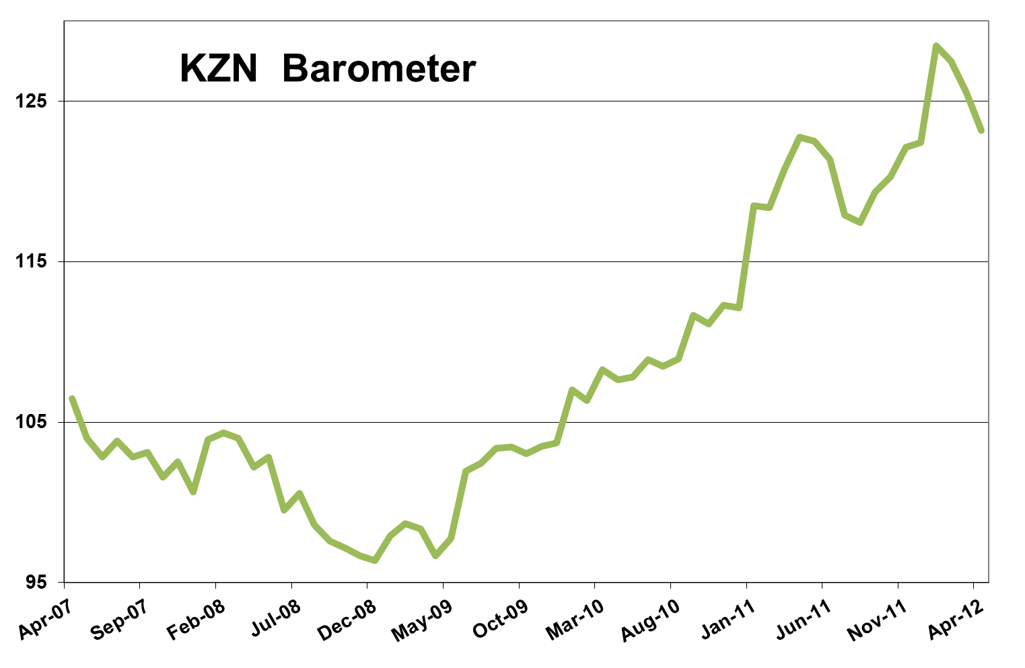
KwaZulu-Natal in growth slump
The KwaZulu-Natal economy seems to have fallen into somewhat of a growth slump. The latest KwaZulu-Natal barometer, as compiled by Mike Schssler of Economists.co.za, grew by only 0.3% year-on-year, the slowest growth since the so-called Great Recession of September 2008. The province’s economy contracted by 0.3% year-on-year in April – the first contraction since February 2010.
Inflation, unemployment and civil debt putting pressure on KZN economy
Part of the weak performance of the KwaZulu-Natal barometer can be ascribed to the increased economic stress. The KwaZulu-Natal economic stress index declined by only 0.7% year-on-year, its smallest decline in 19 months, and on a month-on-month and quarter-on-quarter basis it increased. The slower decline is economic stress is due to the inflation rate in KwaZulu-Natal staying stubbornly high at 6.6%, compared to the national inflation rate of 6% in April. The employment index in KwaZulu-Natal is also losing steam with the unemployment rate increasing to 20.9% compared to 20.5% the previous month. Although the number of civil debt is still falling, the decline has slowed to 37.5% compared to a rate of more than 40% in the previous four months. All of these factors adversely affect the consumer and, in turn, the KwaZulu-Natal barometer.
Mining’s lesser role in KZN a saving grace
Still KwaZulu-Natal’s performance is certainly not the worst in the country. When comparing coastal provinces like KwaZulu-Natal and the Western Cape to inland provinces, it is clear that inland provinces rely more on mining in general to support their economies. The gold and platinum sectors have endured particularly negative incidents since the beginning of the year, with declining prices and production hitches due to long strikes. The province’s exports rely on these mining sectors and consequently took a knock. The whole of South Africa’s economy slowed in recent months due to the decrease in mining activity. KwaZulu-Natal’s mining sector mostly consists of coal mining and was not affected nearly as much as some of the inland provinces. Still, the fall in coal price is starting to have an adverse effect on the province’s mining sector. The KwaZulu-Natal mining index grew by only 1.2% year-on-year in April and declined by 3.8% month-on-month and 3.3% quarter-on-quarter.
Consumer imports support transport and communication
Apart from a smaller reliance on mining than some other provinces, KwaZulu-Natal is also somewhat insulated from the major slowdown, with SA still importing a vast amount of consumer goods. Although the consumer boom is slowing down, it is still big enough to increase imports, benefiting KwaZulu-Natal’s two harbours. The activity at the harbours of Durban and Richards Bay is reflected in the KwaZulu-Natal transport and communication index. The index increased by 7.1% year-on-year – the second-fastest growing index in the KwaZulu-Natal barometer – but declined on a month-on-month and quarter-on-quarter basis. The volume of cargo handled at the two harbours grew by 0.9% year-on-year – the slowest growth in just over a year. This was mainly due to exports not doing very well, but imports still helped to fuel growth. Growth in passenger arrivals at the King Shaka International Airport was slightly negative for the second month in a row. Although this is not too concerning, it should be seen against a background of nearly 30 months of growth in passenger arrivals. Land transport in KwaZulu-Natal still grew with double digits year-on-year. The African growth story continue to make an important contribution to land transport volumes in KwaZulu-Natal, but it also seems to come more from imports than exports. The communications side of the index grew by 9.7% year-on-year. The slowdown after some months of double-digit growth is signalling that the cell phone industry is maturing, with growth mainly coming from the internet and data side.
Trade surprises amidst high consumer pressure
The KwaZulu-Natal trade index was the best performer in the province’s barometer. The index grew by 7.4% year-on-year, 0.6% month-on-month and 1% quarter-on-quarter. Despite the apparent pressure on the consumer, vehicle sales still grew by 5.9% year-on-year and retail sales by 5.3%. This was the weakest year-on-year growth in retail sales since last November, but it showed consumers are still spending money. Petrol sales were up 1.2% on a year ago. The decline in the petrol price, due to lower international oil prices, could help consumers breath a bit easier in coming months. Wholesale figures were up 13.4% year-on-year, but this most likely had more to do with the sale of metals, and coal sales to Eskom, than with retail demand.
Electricity usage down due to maintenance programmes
The KwaZulu-Natal electricity index was negative year-on-year for the first time in four months. The 2.2% decline in electricity usage was due to Eskom’s maintenance programmes and requests to large industrial businesses to cut back on power used during maintenance periods. KwaZulu-Natal was probably affected more by this than other provinces because of the large aluminium smelters in Richards Bay.
Manufacturing growth despite electricity cutbacks
The manufacturing sector is one of the major electricity users in KwaZulu-Natal, but despite aluminium producers being told to cut back on electricity consumption, the province’s manufacturing index still grew by 4.5% year-on-year and 2.7% quarter-on-quarter.
Agriculture growth figures still gloomy
Agriculture in KwaZulu-Natal is still struggling. The 6.4% year-on-year decline is the eleventh consecutive decline in the province’s agriculture index. The index was down 4.8% quarter-on-quarter, but turned slightly positive on a month-on-month basis in April after declining for the previous three months.
Construction disappoints
The biggest struggle seems to be in the construction sector in KwaZulu-Natal, see Results table below. The province’s construction index fell by 14.8% year-on-year, its biggest decline in 13 months. Quarter-on-quarter the index fell by 13.5%. Even though a negative picture was expected, the massive declines were disappointing, as the sector was expected to pick up again. It is likely that the early construction boom of late last year was a bit too early and could have delayed the eventual construction turnaround for another few months. Nonetheless, construction is a lagging indicator and could start to improve again in the last part of the year.
Finance, real estate and business services suffer due to construction woes
The weaker construction figures are echoed in the 0.6% year-on-year decline in property transfers, the second consecutive decline. Mortgages were down 0.5%, showing a bit of a slowdown in the property market. This contributed to the 8.1% year-on-year decline in the KwaZulu-Natal finance, real estate and business services index. The index’s decline was also fuelled by the continued decline in civil debt cases and a 15.8% year-on-year drop in advertising. The decline in money spent in advertising is probably due to the perception that the consumer is under a bit of pressure.
Government spending still in correction phase
Spending by the national, provincial and local governments in KwaZulu-Natal declined year-on-year for the second consecutive month, this time by 11.1%. This is merely a temporary correction after some substantial growth in government spending last year. Spending by municipal and local governments in KwaZulu-Natal will resume in the next few months. The weak government spending figures compounded the effect of the weaker mining and construction data, but this does not mean the KwaZulu-Natal economy is near a recession like the one recorded in September 2008. KwaZulu-Natal is merely in a growth slowdown phase where growth will not be quick, and the new normal for the next few months will be the average of below-average economic growth.
Results Table: April 2012


